**Top Bird**

The cards of birds will be will each have five categories, one will be highlighted and its players diction if the card next to it is higher or lower in the same category.

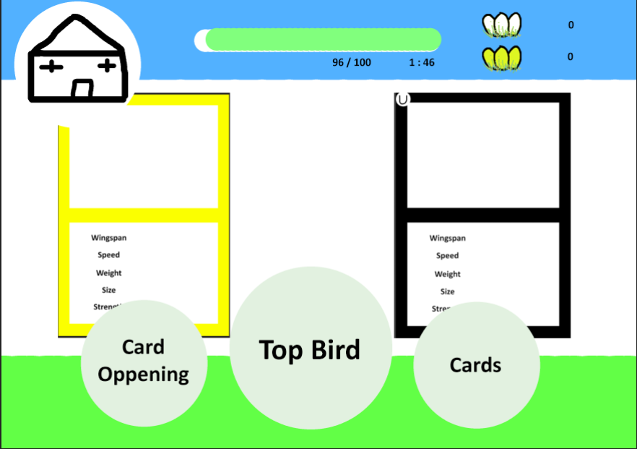

Top Bird will have a competitive feel to it. The object of this game is to collect all the cards of birds that have different with shapes and colours. The cards are displayed like a top tump having five different categories. The player can gain these cards in cards summons with two types of resources “Eggs” and “Golden Eggs”, one havening the possibility to get higher rarity cards. To gain these resources the player must play a high and low game where a card will show up on the left with one of the five categories highlighted, another card on the right will show up showing everything but the categories and with that player must decide if the card on the right with the same category is higher or lower than the one on the left.

**Target audience**

The target audience for this game is towards children and to anyone that is interested in birds. This game will be made like a gacha game so Top Bird target audience will also drone to some who likes this type of game. This game can be played on PC and/ or phone.

This is the LPM loop for Top Bird.

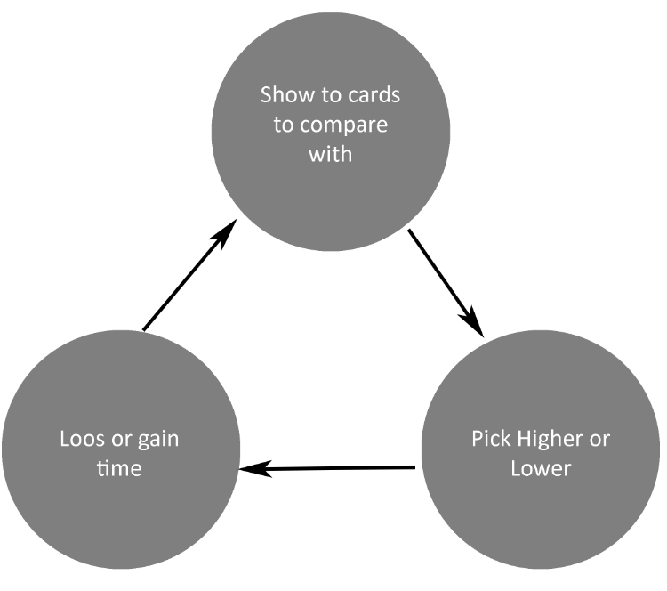

There are four types of fun, and Top Bird goes in easy fun and series fun. The player will start off with three cards in total coming from the common category also when they roll for new cards the player will experience easy fun as they may get new cards. The series fun that the player will feel will be the diction making of the cards category being higher or lower than the other one, the player may also look at the card art to have a sense on with one it is or they may remember the numbers of the cards.

**Gameplayer Overview**

Top Bird will be a gacha basted 2D game in a Landscape display.

The player will start with a home screen with fore different buttons, one with a picture of a home in a circle representing a “Home” which is seen in the top left of the screen, three with writing in the middle of a circle: “Cards Opening”, “Top Bird” and “Cards”. All three button are at the bottom of the screen. The Card Opening button is seen between the left and the middle of the screen, the Top Bird button, which is slightly bigger, is in the middle of the screen and the Cards button is between the middle and the right side of the screen.

Next to the Home button, there are a stamina bar and two different images of eggs, one being golden. The stamina bar has 100 points on it and if one point was to be used it would take 2 minutes to fill that point back up so it would take 3 hours and 18 minutes to fill up from 0.

The images that are under the stamina bar represent how many of that type of egg the player has will be shown with a number directly next to the image on the right.

When the **Card Opening** button is selected another screen will show up showing two different card summonses, each having their own picture showing the cards that are in it, which the player can click on, one using the common “Eggs” drop that the player can obtained with every game and on using “Golden Eggs”, to gain these eggs will be explained later. This is where the worn asset will be obtained.

In the **Card** screen the player will see all the cards they have and have not got. If the player has not got a certain card, then it will show a black outline of a card with a question mark in it. If they have the card then the card art, the five category and the numbers preside them will show. The order of the cards will be from common to rainbow rarity.

The button **Top Bird** leads to the main game machine which is also the LMP loop. To play Top Bird the player will lose 20 points of the stamina bar, this will be displayed at the top of the Top Bird button. The player will be able to play this five times before having to wate for it to regenerate. This is where the high and low game starts. The cards that the player can get will display here. The player also gains the Egg and Golden Egg here.

To get the player to keep playing this then the compulsion loop starts off with the trigger which is the Top Bird button. The action is the player choosing Higher or Lower. The reward is the Eggs and Golden Eggs which get displayed at the top under the stamina bar. The player can gain an Egg or Golden Egg when getting one High or Low correct. These are what give the player the chance to gain cards. Which leads to the investment, the player wants to get more Eggs to summon and get all the cards.

**Mechanics**

**Cards Button**

Here the player will be able to see all the cards they can get and have got. The cards will be placed from left and right. The cards will have all their art and categories shown if the player has obtained it. If the player hasn’t obtained the card, it would be replaced with a black and white question mark.

**The 64 Cards**

There are 30 common cards, 18 uncommon cards, 9 rare cards, 4 epic cards, 2 legendary cards and 1 rainbow card adding to 64 cards.

**Upgrade**

There is a green button named “Upgrade” in the top left corner of the card art where the player can choose to upgrade the style of a card art except common cards. The player will need 5 worms for a particle effect and additional 10 worms for an animation effect.

**Card Categories**

The categories that, are at the bottom of the art, are Wingspan, Speed, Weight, Size and Strength and each card has these categories differently for an example Wingspan could be 40 for one card and 22 for another. The numbers on each category varies depending on the rarity of the card so the rarer the stronger and the card itself. The higher the speed the lower everything else is.

|  |  |  |  |  |  |  |
| --- | --- | --- | --- | --- | --- | --- |
|  | **Common** | **Uncommon** | **Rare** | **Epic** | **Legendary** | **Rainbow** |
| **Wingspan (centimetres)** | 10-50 | 30-70 | 50-90 | 70-110 | 92 and 134 | 140 |
| **Speed (Mil/H)** | 5-25 | 15-35 | 25-45 | 35-55 | 47 and 66 | 70 |
| **Weight (Grams)** | 40-80 | 70-110 | 80-120 | 100-150 | 131 and 178 | 180 |
| **Size (centimetres)** | 15-55 | 35-75 | 55-95 | 75-115 | 100 and 135 | 145 |
| **Strength (Kg of weight)** | 4-8 | 6-10 | 8-14 | 12-16 | 14 and 18 | 20 |

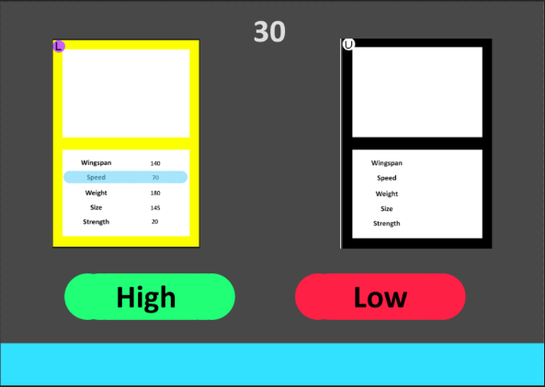**Top Bird Button – look right for reference**

The game play starts off with showing two cards, on the left shows a card with all the art and the five categories with one of them highlighted, on the right shows a different card with all its art but without the five categories. There are two buttons at the bottom of the cards one saying Higher and the other saying Lower. The player’s job is to choose if the number of the category of that card is higher or lower than the other card on the same category, the player will have 30 seconds before the game finishes but if the player gets it right then 10 seconds is added. Then another two cards show up.

**Cack Opening Button**

There are two types of summoning pulls the player can do, one is with “Eggs” which is called “Top Bird” and the other is with “Golden Eggs” called “Golden Top Bird”. With the “Top Bird” summon pull the player can use five eggs to summon for one card or use 45 eggs and get 10 which means the player get one for free.

With “Golden Top Bird” summoning pull then player can summon for one card by using one golden egg or use five golden eggs and get five cards. In this summoning pull there are no common or uncommon cards but the chance of getting the random card is still low as shown below.

The player can see these rating if they click on the little magnifying glass in the top right side on the summoning title.

|  |  |  |  |  |  |  |
| --- | --- | --- | --- | --- | --- | --- |
|  | **Common** | **Uncommon** | **Rare** | **Epic** | **Legendary** | **Rainbow** |
| **Top Bird** | 46.9% | 28.1% | 14% | 6.3% | 3.1% | 1.6% |
| **Golden Top Bird** | N/A | N/A | 56.25% | 25% | 12.5% | 6.25% |

**Rewards**

**In Top Bird**

The player will gain 1 Egg every 15 seconds and also has an 40% chance for every higher or lower correct. The player has also got an 10% chance for every higher or lower correct. If the player gets 5 high and lows correct back-to-back, they gain a Golden Egg.

**Summoning**

When the player is summoning for cards and they gain a card they already have got they gain worms, the more the rare the card the more worms, that is used to upgrade any card they like. The upgrades will change how the card looks with animations and particles.

|  |  |  |  |  |  |  |
| --- | --- | --- | --- | --- | --- | --- |
|  | **Common** | **Uncommon** | **Rare** | **Epic** | **Legendary** | **Rainbow** |
| **Worms** | N/A | 1 | 2 | 3 | 4 | 5 |

**Visual Design**

**Particles**

Uncommon and Rare cards will only have the option to upgrade once leading the too have only a particle effect.

For Uncommon cards the particles will have sticks falling down starting from the top of the bird card art till the bottom of it.

For Rare cards the particles will have white grass blades fly by from bottom left to top right of the bird card art.

For Epic cards the particles will have white feathers fly by from top left to bottom right of the bird card art.

For Legendary cards the particles will have leaves fly by from right to left of the bird card art.

For the Rainbow card the particles will have pick flower petals fly by from right to left of the bird card art.

**Animation**

Rare and Epic cards will have their wings flapping as if they are taking off (Rare) and flying up (Epic).

Legendary and Rainbow cards don’t just have the bird art but also the boarder as will. There are wind streaks showing them that they are gliding.

The boarder of Legendary cards will have a wave of shine going from top left to bottom right.

The Rainbow cards’ boarder will glow with the birds colours.

**Cards Art**

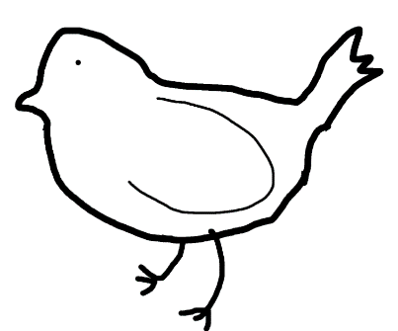For each rarity of card, they will have their own silhouette of a bird showing each stage of bird and the colours and shapes that will be on their feathers. In the background of each bird will show the same theme with them in some wildlife area for example: flower field, forest, tall grass or on a tree branch. The size of the bird will take up more than 50% of the area and will be in the middle of where it is framed.

**Common Card Art**

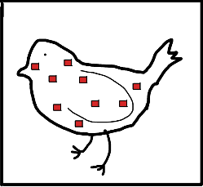The 30 common cards will be divided into four patterns, one plane and six colours. Each birds’ feathers will be white except the plane bird. The patterns are squares, circles, triangles, stripes. The six colours are green, blue, red, yellow, orange and brown. One shape will have one of each colour. The silhouette of the bird will have its wings folded in.

The borders for these cards will be black with a small white circle in the top right corner with a “C” in it.

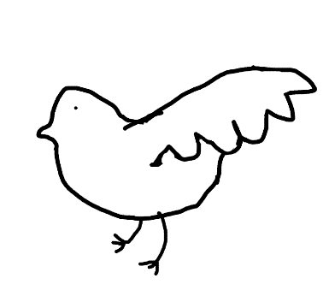**Uncommon Card Art**

There are 18 uncommon cards and the shapes on them are squares, triangles and circles with one of each colour. The birds’ wings will be spread out but not flying.

The borders for these cards will be black with a small grey circle in the top right corner with a “UC” in it.

**Rare Card Art**

The 9 birds in rare category of cards are light blue with the shapes on their feathers being: triangles, circles and stripes. Each shape will have 3 colours each being, red, orange and green. The bird silhouette will look like that it is taking of.

The borders for these cards will be the same colour as the bird with a small orange circle in the top right corner with a “R” in it.

**Epic Card Art**

The 4 birds in the cards will have their feathers coloured light green, a lighter green than the shape colour. The bird silhouette will look like the bird is fly upwards in the. The four shapes on these birds are squares coloured blue, circles coloured yellow, stipes coloured red and the last one left as it is.

The borders for these cards will be the same colour as the bird with a small red circle in the top right corner with a “E” in it.

**Legendary Cart Art**

The 2 Legendary cards have the birds feathers yellow with them both have strips as their shape, one being coloured green and the other coloured blue. There silhouettes will look like they are gliding in the air.

The borders for these cards will be golden with a small purple circle in the top right corner with a “L” in it.

**Rainbow Card Art**

There is only one card for Rainbow and that have all the colours but brown so: red, green, blue, yellow and orange. The colours will be placed in stripes one other the other repeatedly. This time there are three birds on the same cards one behind the other.

The borders for these cards will be the same colour as the bird with a small golden circle in the top right corner with a “R” in it.

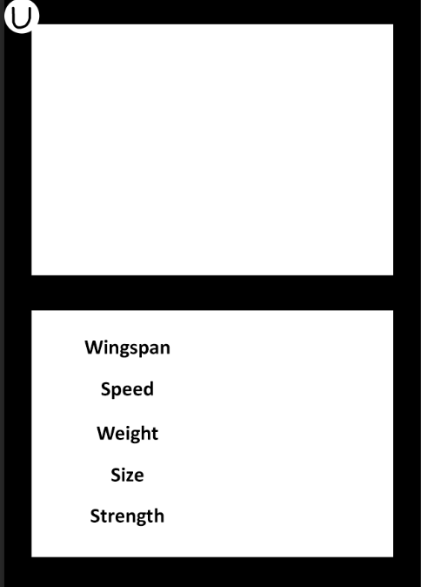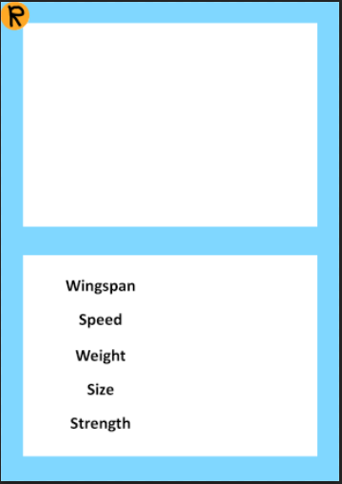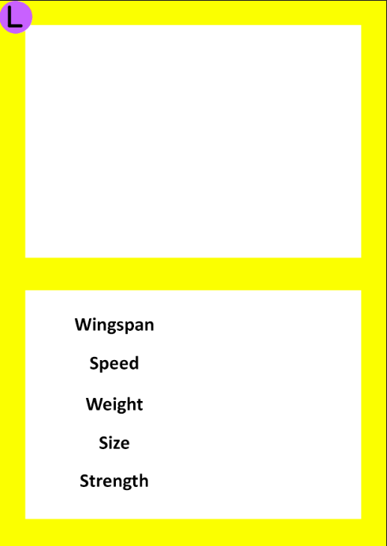

**Sound**

On the main menu there will be quite wind blowing and soft music in the background with a distinctives sound of birds chipping.

When the player clicks on a button on the UI it will make the sound of a bird taking of.

As the player clicks on the high button in Top Bird it will make a lower pitched bell sound than the low button.

**Worm**

The worms the player can obtain through card summons are just like mealworms.